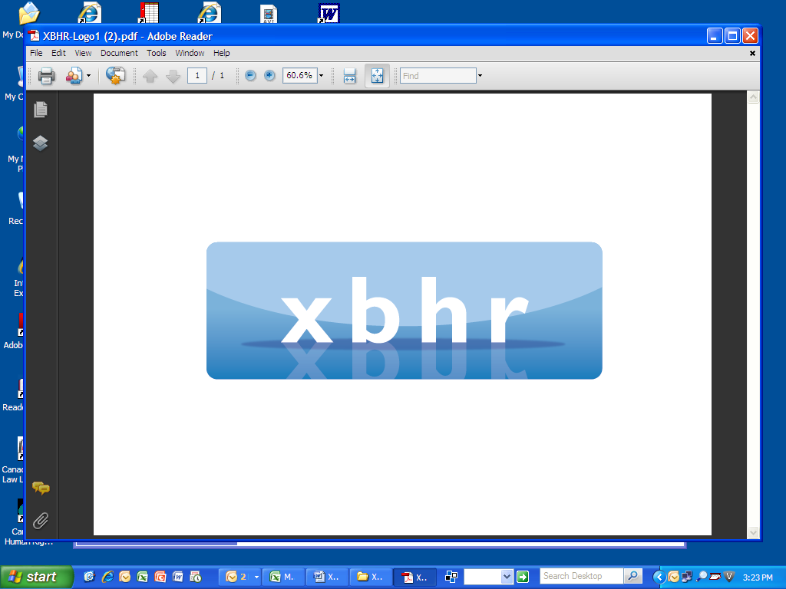

**ANNUAL CONFERENCE**

**The Challenges of this Decade for HR**

**March 5-7, 2025**

**Turin, Italy**

**Palazzo Marone Cinzano – Pininfanna Room**



**Suggested hotel: Hotel Turin Palace Hotel**

**Via Paolo Sacchi 8, Torino, Italy**

**Wednesday, March 5, 2025**

6:30 pm - 9:00 pm **Welcome Drinks and Networking** at Floor 35 Lounge Intesa San Paolo Tower

**Thursday, March 6, 2025**

8:00 am **Registration Opens: Informal Networking Breakfast**

9:00 am Welcome by Gunda Niehaus (*P & G*) - Chair of XBHR;   
Andrea Schwartz (*Dynatrace*) and Mercedes Balado Bevilacqua (*MBB Lawyers*) - Co-Chairs;

2025 Conference Co-Chairs

Vittorio Torazzi (*Pavesio Associati*) & Marco Finanzieri (*Dumarey*) – Host committee 2025

9:10 am Brief individual introductions

9:35 am **AI & HR - Best practice Uses & Experiences**

**Discussion Leader:  Gerlind Wisskirchen and Roselyn Sands**

**-** Recruiting using AI

**-** Monitoring performance through AI tools?

*-* EU AI Act & NY Rule 144 and other regulations around the world

*-* Other uses and experiences

10:45 am Break

11:00 am **Global Mobility & Immigration**

**Discussion Leader: Baba Zipkin**

* Digital Nomad workers
* Remote work and Multijurisductional issues to takle.

12:15 pm **Annual General Meeting of XBHR**

1:00 pm **Lunch: Key note speaker: prof. Giuseppe CASALE – former Director of ILO School of Development at the International Training Ceneter of the ILO in Torino - professor of International and comparative labor law, University of Torino.**

1:45 pm **New HR Issues relating to flexible working**

**Discussion Leaders: Andrea Schwartz and Gunda Niehaus**

* Managing performance/succession planning remotely
* Controlling working time /overtime work
* Monitoring employees - How much is too much?
* Prohibiting and monitoring multiple employment

3:15 pm **Break**

3:30 pm **Equal treatment in employment** – **what does the future hold?**

**Discussion Leaders: Vittorio Torazzi and Marco Finanzieri**? To be confirmed

- The EU Equal Pay Directive

- D&I Post UNC v. Harvard?

- Is the world waking up just when the backlash hits the US?

- Age as a factor?

-Quotas for boards?

5:00 pm **Closing Remarks**

6:30 pm **Drinks Reception and Gala Dinner** at Accorsi-Ometto Museum of Decorative Arts

**Friday, March 7, 2025**

8:00 am **Informal Networking Breakfast**

9:00 am **Labor Relations Around the World**

**Discussion Leaders: Gerlind Wisskirchen, Mercedes Balado and Filip Saelens**

-New reforms in labor laws and trends in Latin America

-European Union latest directives.

- How these reforms and new trends affect HR and business

-Union reactions to reforms

- Social and economic impact of reforms.

10:30 am **Break**

10:45 am **Restrictive covenants: What’s new?**

**Discussion Leader: Carolyn Knox and Gunda Niehaus**

* Non-competes, Trade secrets, Non-solicitation clauses
* Impact of people moving to competition
* Developing strategies to protect companies assets

12:30 pm **Lunch**

1:30 pm **The World Under trump II: What has been done, what can we expect and how to prepare for it?**

**Discussion Leader : Roselyn Sands**

-Will countries follow his lead?

* Cutting government to reduce deficits?
* Immigration /deportation?
* Tariffs impact on employment?
* Will the US lose its lead or regain more leadership?

- What are CEOs thinking? Impact on employment?

3:15pm **Closing Remarks**

4:00 pm **Business Meeting of XBHR Management Committee**

7:00 pm **Volunteered Networking Dinner** (to be paid separately)