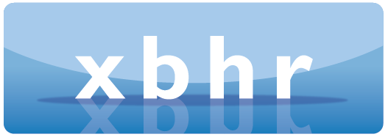

ANNUAL CONFERENCE

The Challenges of this Decade for HR

March 5-7, 2025
Turin, Italy

Palazzo Marone Cinzano – Pininfanna Room



CONFERENCE REGISTRATION FORM

I apply to register for the Conference to take place 5th – 7th March, 2025
Full name (and title):
Organisation:
Address:
Profession:
Telephone:
Email:
I will attend the welcome drinks and networking event on the evening of Wednesday 5th March |  | Yes  | No 
I will attend the cocktail reception and gala dinner on the evening of Thursday 6th March |  | Yes  | No 
I am interested in bringing a guest to the cocktail reception and gala dinner on Thursday 6th March (there will be an additional cost for guests who will be included subject to availability, and places will be allocated on a first come first served basis depending on when the request is received, after conference delegates have been accommodated). |  | Yes  |  | No 
Do you have any special dietary requirements? If yes, please give details. |  |  |  |  |  | Yes  | No 
Would you be interested in attending a voluntary post-conference dinner on Friday 7th March? |  | Yes  |  | No 
Upon acceptance of your registration application, you will be sent an invoice for the registration fee of
₤395/€480/US$500.

Cancellation Policy
Delegates may cancel their registration and will be reimbursed the registration fee paid minus a 15% administration fee, provided that the XBHR Administrator is notified in writing before Monday 17th February, 2025. After that date no refund can be given. Substitution of delegates is permitted. XBHR reserves the right to cancel the Conference if it deems it necessary and will, in such event, refund registration fees in full. XBHR accepts no liability for changes in programme date, content, speakers and venue.

Circulation of Delegate Details
Would you be happy for us to include your contact details on a distribution list of delegates? | Yes  | No 

When completed, please send this form to:

Philippa Rimell, XBHR Administrator

Email: admin@xbhr.co.uk
Address: Flat 3, Avenalls Court, Avenalls Parade, Cheltenham, GL53 7QQ, UK

XBHR will assist delegates as far as practicable in seeking continuing education credit from certifying bodies.

